**ex3.html**

<html>

<head>

<script src="formea.js"

type="text/javascript">

</script>

<style type="text/css">

table{

width:100%

}

</style>

</head>

<body>

<form>

<table border="1">

<caption>COMPLAINT REGISTRATION FORM</caption>

<tr>

<td colspan="2">

<label>District*:

<select id="s1" autofocus required>

<option disabled selected value="">--select a district--</option>

<option value="ariyalur">Ariyalur</option>

<option value="chennai">Chennai</option>

<option value="kovai">Coimbatore</option>

<option value="kanchi">Kancheepuram</option>

<option value="salem">Salem</option>

<option value="tanjore">Tanjore</option>

</select>

</label>

</td>

</tr>

<tr>

<th> Details Of Complainant</th>

<th> Details Of Complaint</th>

</tr>

<tr>

<td>

<label>Name*:

<input id="nameid"

type="text"

placeholder="Complainant Name"

onblur="checkName(id)"

>

</label>

</td>

<td rowspan="2">

<label>Subject*:

<select id="s2" required>

<option disabled selected value="">--select a subject--</option>

<option value="road">Roads</option>

<option value="tax">Taxes</option>

<option value="current">Electricity</option>

</select>

</label>

</td>

</tr>

<tr>

<td>

<label>Gender

<br>

<input id="i2"

type="radio"

name="Gender"

value="male"

checked

onchange="checkGender(id)"

> Male

<br>

<input id="i3"

type="radio"

name="Gender"

value="female"

onchange="checkGender(id)"

> Female

<br>

<input id="i4"

type="radio"

name="Gender"

value="other"

onchange="checkGender(id)"

> Other

</label>

</td>

</tr>

<tr>

<td>

<label>Date Of Birth*:

<input id="idate" type="text" placeholder="DD-MM-YYYY" onchange="checkDob(id)" required >

</label>

</td>

<td>

<label>Date Of Occurence:

<input id ="i5" type="text" placeholder="DD-MM-YYYY" onchange="checkDob(id)" required >

</label>

</td>

</tr>

<tr>

<td rowspan="2">

<label>Address

<textarea id="addid"

name="Address"

placeholder="Complainant Address"

onblur="checkAdd(id)"

></textarea>

</label>

</td>

<td rowspan="2">

<label>Place Of Occurence:

<textarea cols="45" name="address" placeholder="Place Of Occurence( max 200 characters)"></textarea>

</label>

</td>

</tr>

<tr>

</tr>

<tr>

<td>

<label>Mobile Number

<input id="mobid"

type="text"

placeholder="Complainant Mob No"

onblur="checkNo(id)"

>

</label>

</td>

<td rowspan="2">

<label>Description:

<textarea rows="4" cols="50" name="address" placeholder="Complaint Description( max 2000 characters)"></textarea>

</label>

</td>

</tr>

<tr>

<td>

<label>Email ID:

<input type="text" id="emailid" placeholder="Email ID" onblur="checkEmail(id)">

</label>

</td>

</tr>

<tr>

<td colspan="2">

<label>Education:<br>

<label><input type="checkbox" value="B.E" id="c1" >B.Tech.</label><br>

<label><input type="checkbox" value="M.E" id="c2" >M.Tech.</label><br>

<label><input type="checkbox" value="P.hd" id="c3" >P.hd.</label><br>

</td>

</tr>

<tr >

<td colspan="2">

<label>Want to attach documents[max 500KB (PDF,PNG,JPEG files allowed)]

<input type="radio" name="r2" value="yes" >Yes

<input type="radio" name="r2" value="no" >No

<input type="file">

</label>

</td>

</tr>

<tr>

<td colspan="2" style="text-align:center">

<input type="submit" onclick="display()" value="SUBMIT">

</td>

</tr>

</table>

</form>

</body>

</html>

**form.js**

function checkName(id)

{

var input= document.getElementById(id).value;

if(input==="")

{

window.alert("Name is a required field");

}

else

{

var v1 = new RegExp("^[a-zA-Z]*$");

if(!v1.test(input))

window.alert(input+" is not a valid name");

}

}

function checkGender(id)

{

var x= document.getElementById(id)

if(x.checked === true)

window.alert("Gender is "+x.value);

}

function checkDob(id)

{

var days_of_mon;

var date=document.getElementById(id).value;

if ( date =="")

{ window.alert("DOB is a required field");

return;

}

date=date.split("-");

var day=date[0];

var month=date[1];

var year= date[2];

//window.alert("dob: "+day+month+year);

var dTest = RegExp("^\\d{4}$");

if (year=="" || !dTest.test(year) || year>2020)

window.alert(year+" is an invalid year");

else //yr is valid

{

if ( month=="" || month<1 || month>12)

window.alert(month+" is not an valid month");

else //yr, mon is valid

{

if (day=="" || day<1 || day>31 )

window.alert(day+" is not an valid day");

else

{

year=parseInt(year);

//window.alert("type"+typeof year);

if(year%4==0)

{ days_of_mon=[31,28,31,30,31,30,31,31,30,31,30,31]; }

else

{ days_of_mon=[31,29,31,30,31,30,31,31,30,31,30,31]; }

var idx=month-1;

if (day>days_of_mon[idx])

window.alert("The DOB is invalid!");

else

window.alert("Date is "+day+"-"+month+"-"+year);

}

}

}

}

function checkAdd(id)

{

var input= document.getElementById(id).value;

if(input==="")

window.alert("Address is a required field");

else

window.alert("Your address is: "+input);

}

function checkNo(id)

{

var input= document.getElementById(id).value;

if(input==="")

{

window.alert("Mobile No is a required field");

}

else

{

var v1 = new RegExp("^\\d{10}$");

if(!v1.test(input))

window.alert(input+" is not a valid no");

}

}

function checkEmail(id)

{

var input= document.getElementById(id).value;

if(input==="")

{

window.alert("Email is a required field");

}

else

{

var v2=new RegExp("^(\\w|\\d)*@\\w*.com$");

if(!v2.test(input))

window.alert(input+" is not a valid email-id");

}

}

function display()

{

var str="";

var n = document.getElementById("nameid").value;

str+="NAME : "+n+"\n";

var g = document.getElementById("i2");

if (g.checked)

str+="GENDER: "+g.value+"\n";

var g = document.getElementById("i3");

if (g.checked)

str+="GENDER: "+g.value+"\n";

var g = document.getElementById("i4");

if (g.checked)

str+="GENDER: "+g.value+"\n";

var date=document.getElementById("idate").value;

str+="DOB: "+date+"\n";

str+="ADDRESS : "+document.getElementById("addid").value+"\n";

var m = document.getElementById("mobid").value;

str+="MOBILE NUMBER : "+m+"\n";

var m = document.getElementById("emailid").value;

str+="EMAIL ID : "+m+"\n";

var g = document.getElementById("c1");

if (g.checked)

str+="EDUCATION :"+g.value+"\n";

var g = document.getElementById("c2");

if (g.checked)

str+=" "+g.value+"\n";

var g = document.getElementById("c3");

if (g.checked)

str+=" "+g.value+"\n";

window.alert("***********************DETAILS*************************\n"+str);

}

**OUTPUT**

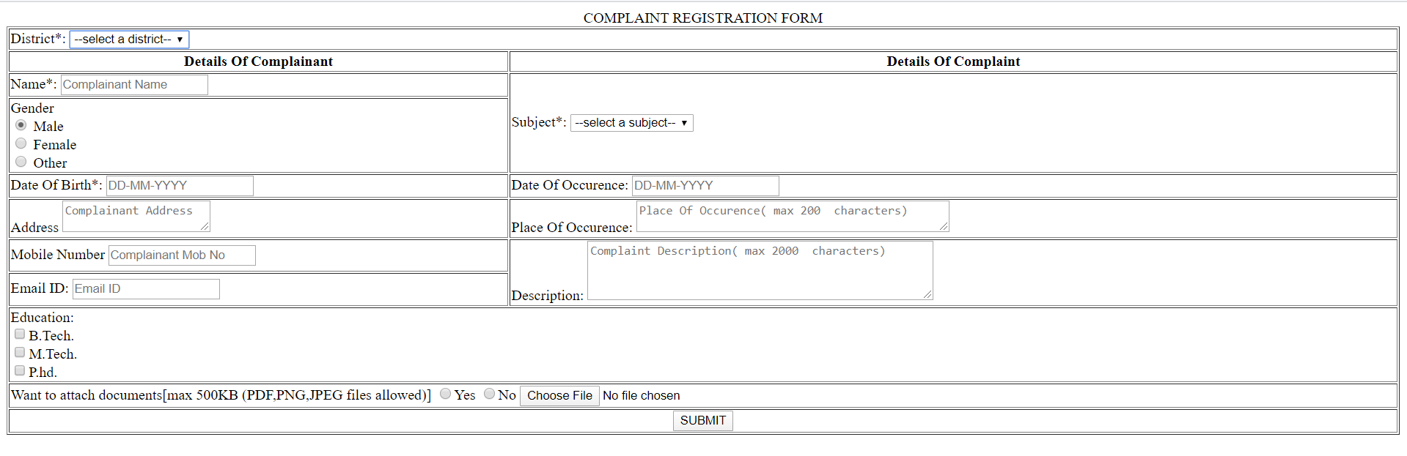

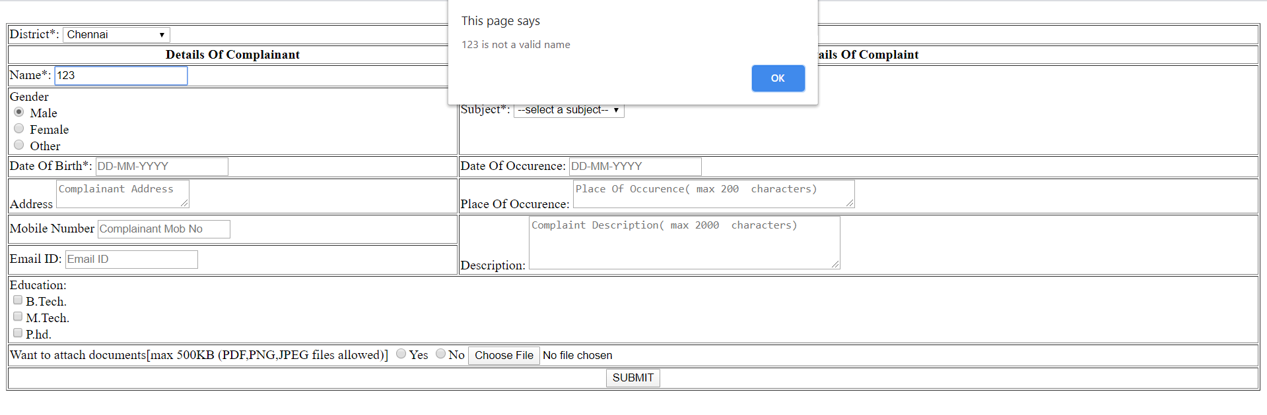

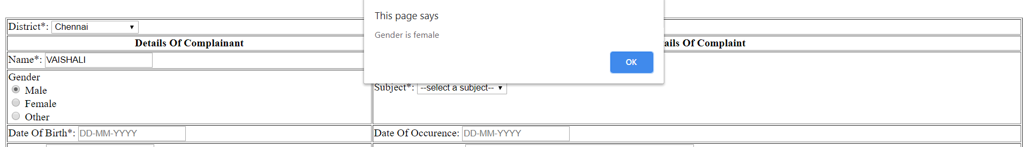

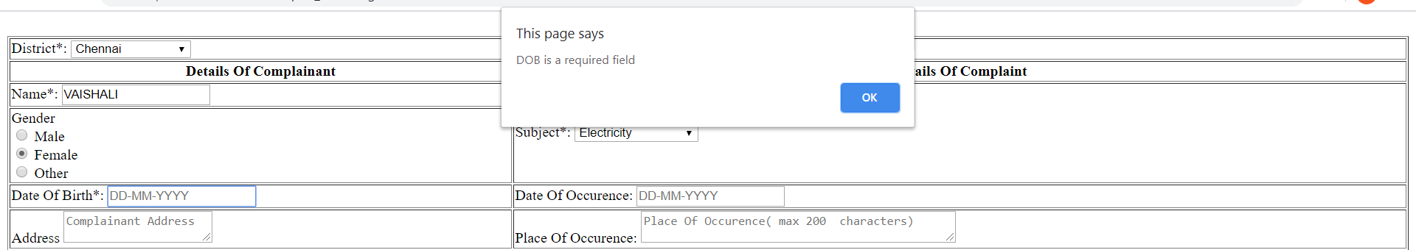

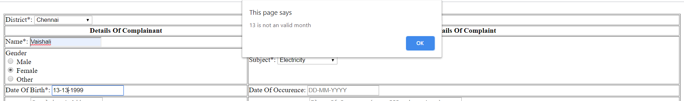

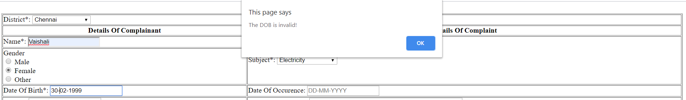

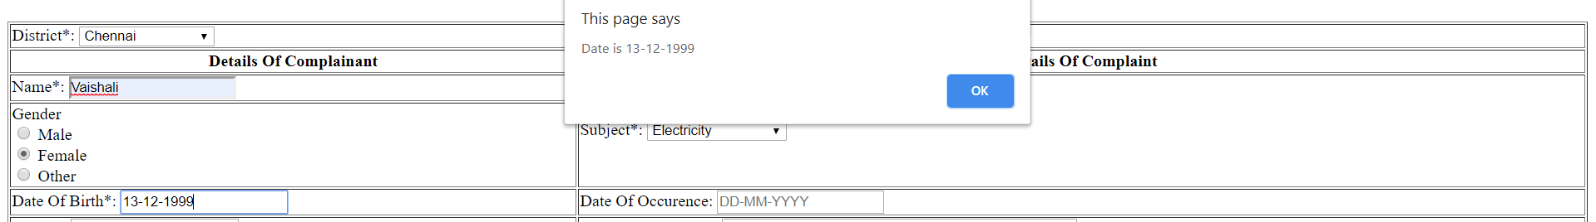

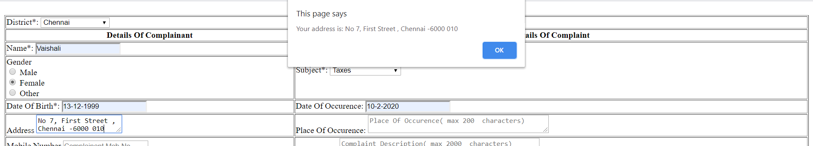

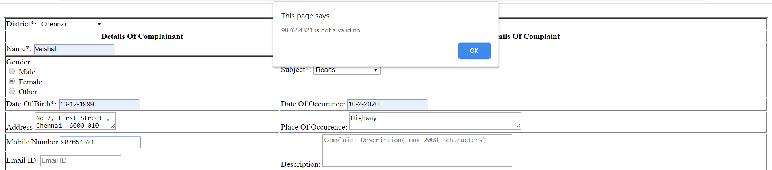

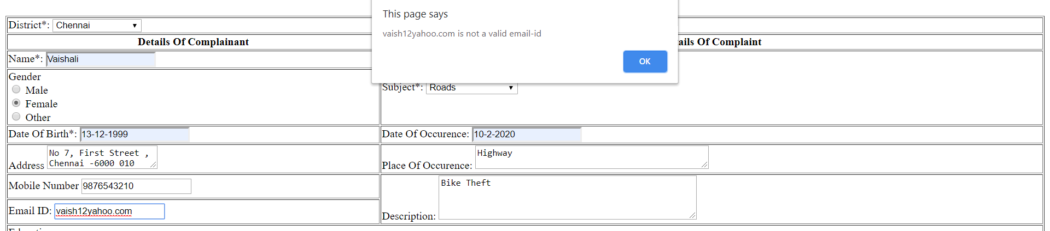

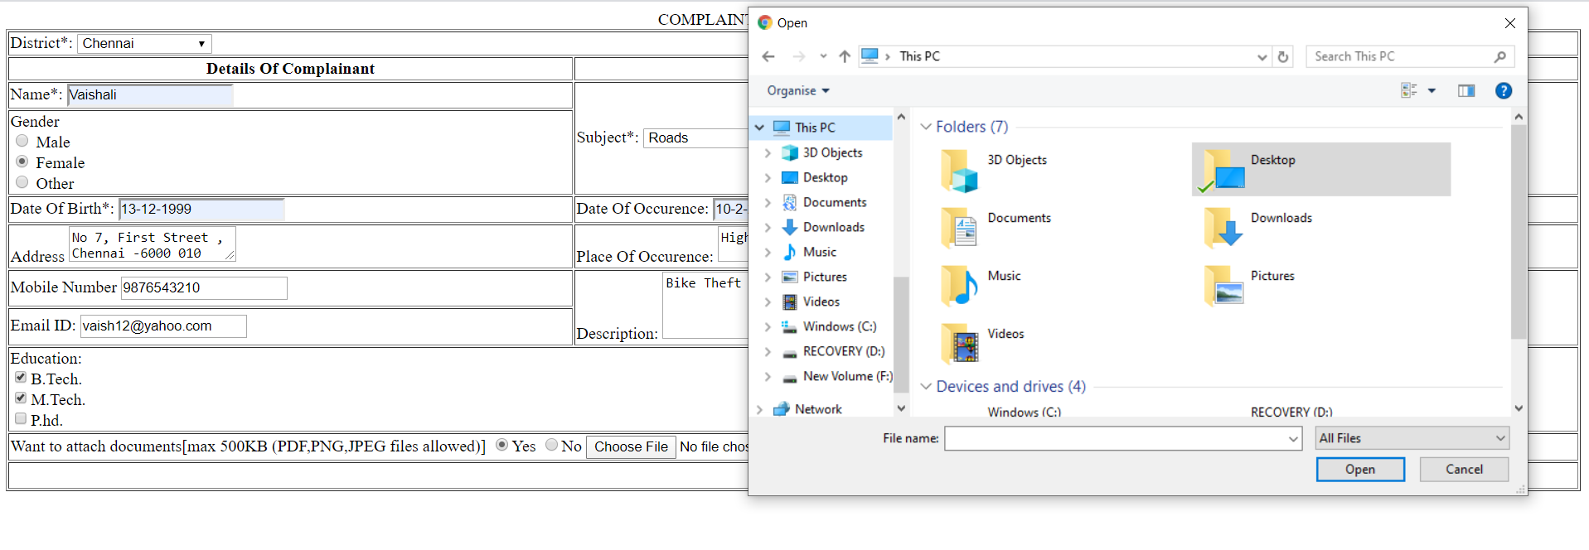

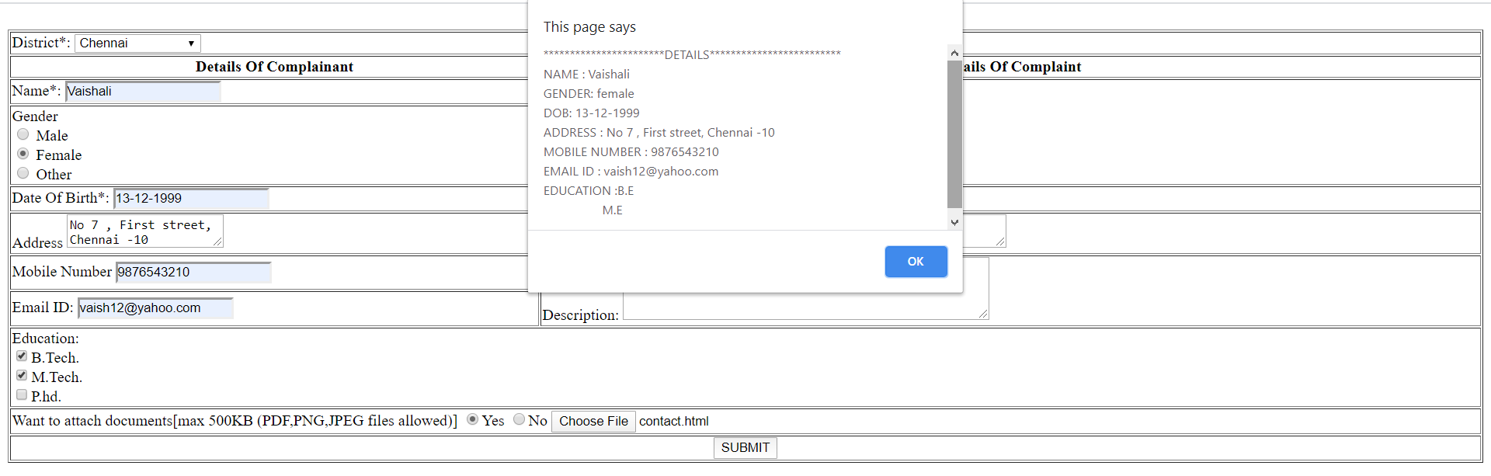

**first.html**

<html>

<body>

<form action="Welcome" method="get">

<label>Click this <input type="submit" value="submit">

</input>

<label>

</form>

</body>

</html>

**hello.java**

import java.io.*;

import javax.servlet.*;

import javax.servlet.http.*;

public class hello extends HttpServlet {

public void doGet(HttpServletRequest request, HttpServletResponse response)

throws IOException, ServletException {

response.setContentType("text/html");

PrintWriter out = response.getWriter();

out.println("<html>");

out.println("<head><title>Hello World</title></head>");

out.println("<body>");

out.println("<h1>Welcome</h1>");

out.println("</body></html>");

out.close();

}

}

**web.xml**

<web-app>

<servlet>

<servlet-name>HelloServlet</servlet-name>

<servlet-class>hello</servlet-class>

</servlet>

<servlet-mapping>

<servlet-name>HelloServlet</servlet-name>

<url-pattern>/Welcome</url-pattern>

</servlet-mapping>

<welcome-file-list>

<welcome-file>first.html</welcome-file>

</welcome-file-list>

</web-app>

**OUTPUT**

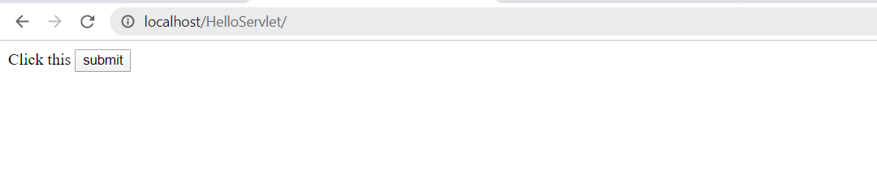

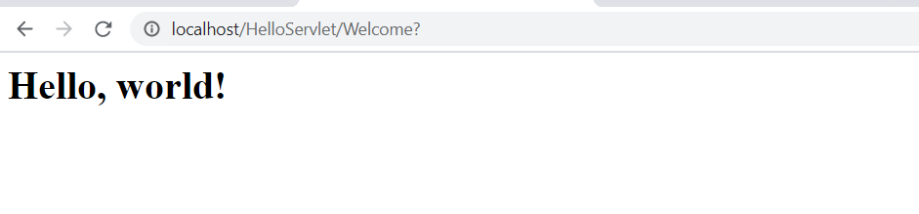

**index.html**

<html>

<body>

<form action="Welcome" method="get">

<label>Click this <input type="submit">

</input>

<label>

</form>

</body>

</html>

**ipdb.java**

import java.io.*;

import javax.servlet.*;

import javax.servlet.http.*;

import java.sql.*;

public class ipdb extends HttpServlet {

public void doGet(HttpServletRequest request, HttpServletResponse response)

throws IOException, ServletException {

response.setContentType("text/html");

PrintWriter out = response.getWriter();

Connection con;

Statement stmt;

ResultSet rs;

String url="jdbc:mysql://localhost:3306/library";

String user="root";

String pass="vaishu";

out.println("<html>");

out.println("<head><title>Data, World</title></head>");

out.println("<body>");

try{

Class.forName("com.mysql.jdbc.Driver");

con=DriverManager.getConnection(url,user,pass);

String sql;

sql="select * from book";

stmt=con.createStatement();

rs=stmt.executeQuery(sql);

while(rs.next())

{

out.println("<p>"+rs.getString(1)+" "+rs.getInt(2)+"</p>");

}

}catch(ClassNotFoundException ex){

out.println("<p>class error"+ex.getMessage()+"</p>");

}

catch(SQLException ex){

out.println("<p>sql error"+ex.getMessage()+"</p>");

}

out.println("</body></html>");

out.close();

}

}

**web.xml**

<web-app>

<servlet>

<servlet-name>DataServlet</servlet-name>

<servlet-class>ipdb</servlet-class>

</servlet>

<servlet-mapping>

<servlet-name>DataServlet</servlet-name>

<url-pattern>/Welcome</url-pattern>

</servlet-mapping>

</web-app>

**OUTPUT:**

